Summary of Meteorite Dataset

Total number of meteorites: 23,032

Two most common meteorites: L6 and H5

Average mass L6 (in g): 2022.17g

Average mass H5 (in g): 3165.19g

In this report, we analyze meteorite composition and classification using data from NASA. Specifically, we examine two of the most common types of meteorites: **L6 and H5 chondrites**. Their properties may provide insights into planetary formation and the evolution of materials in space.

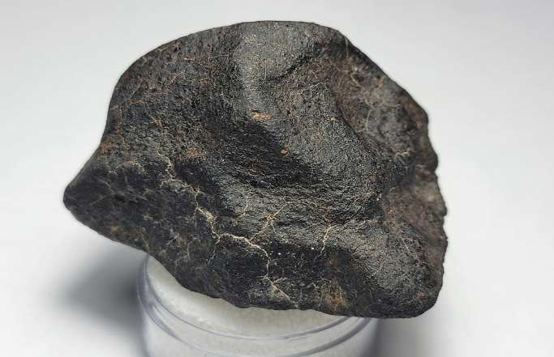

This is an Indian Butte Ordinary Chondrite H5 crusted Meteorite (75.1g)

H5 meteorites provide valuable insights into asteroidal processes, including **core formation, fragmentation, and collision history**.

The **Jilin meteorite** is one of the largest recorded meteorite falls in history! It fell on **March 8, 1976**, in **Jilin Province, China**, and is classified as an **H5 ordinary chondrite. • The Jilin meteorite likely formed from the fractionation-condensation process of the solar nebula, meaning it condensed from gas and dust in the early solar system.**

The largest L6 meteorite was found on Long Island and is named after the location as well. Coming in at 564,000 grams, this L6 meteorite was discovered in 1891 and one of the largest L6 meteorites recovered. The Long Island meteorite is significant due to its **size, composition, and shock features**, which provide insights into asteroid evolution and planetary formation.

Why is this important? Well, we know that Earth’s core is mostly made up of iron and nickel. Iron, being the most common meteorite composite, hints at Earths origin from our very own solar system, and give us more evidence about the formation of the Earth.